**Permit System with Isolation**

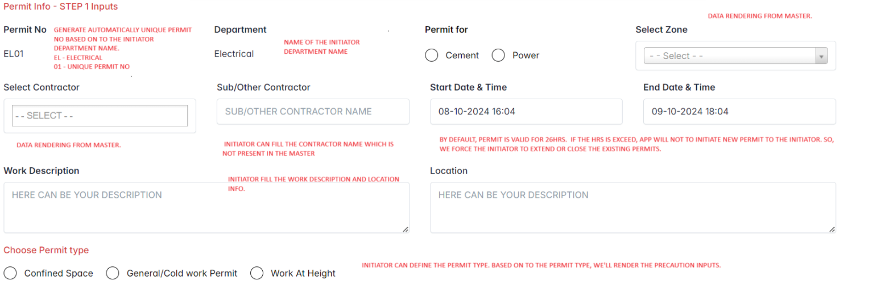

**Confined Space Precautions**

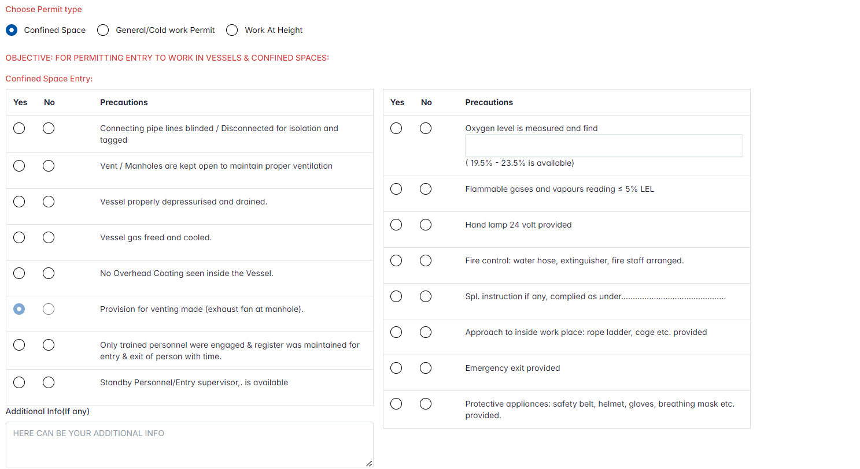

**General work precautions**

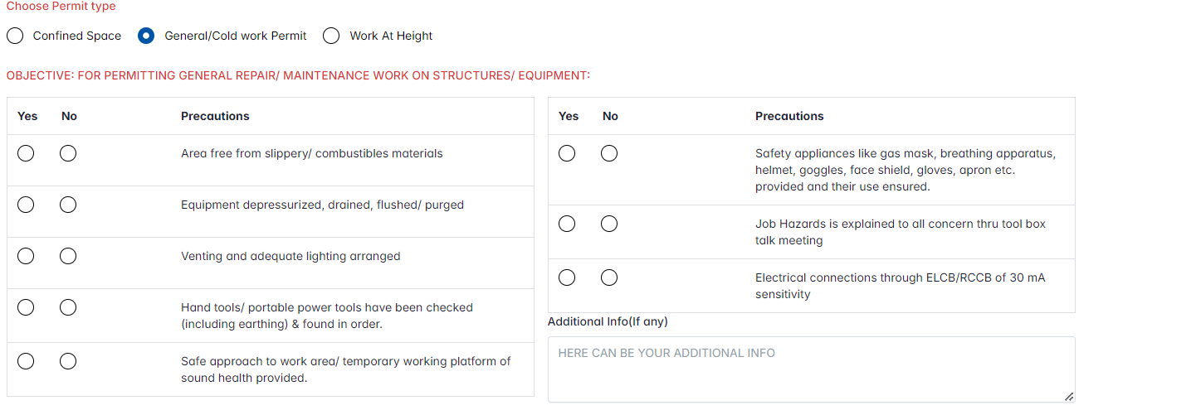

**Work at height precautions**

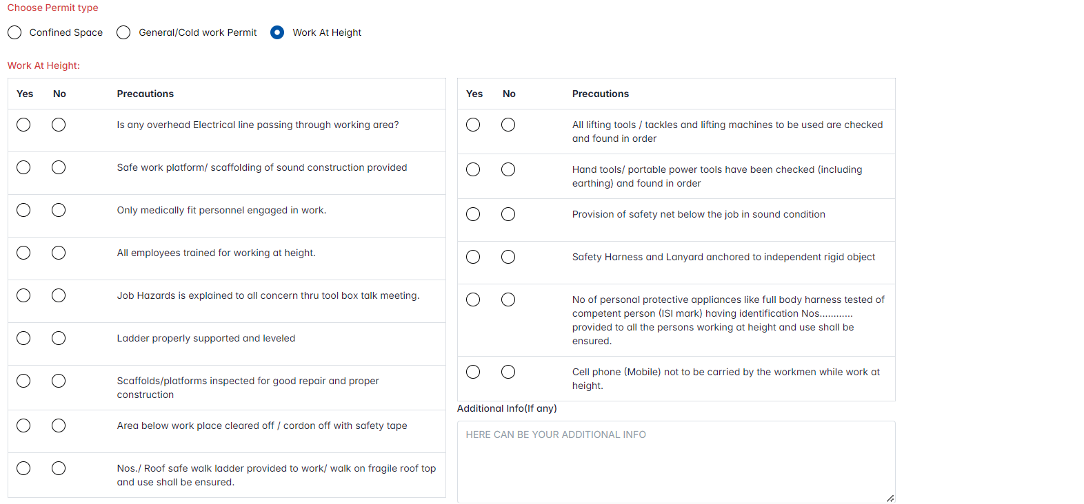

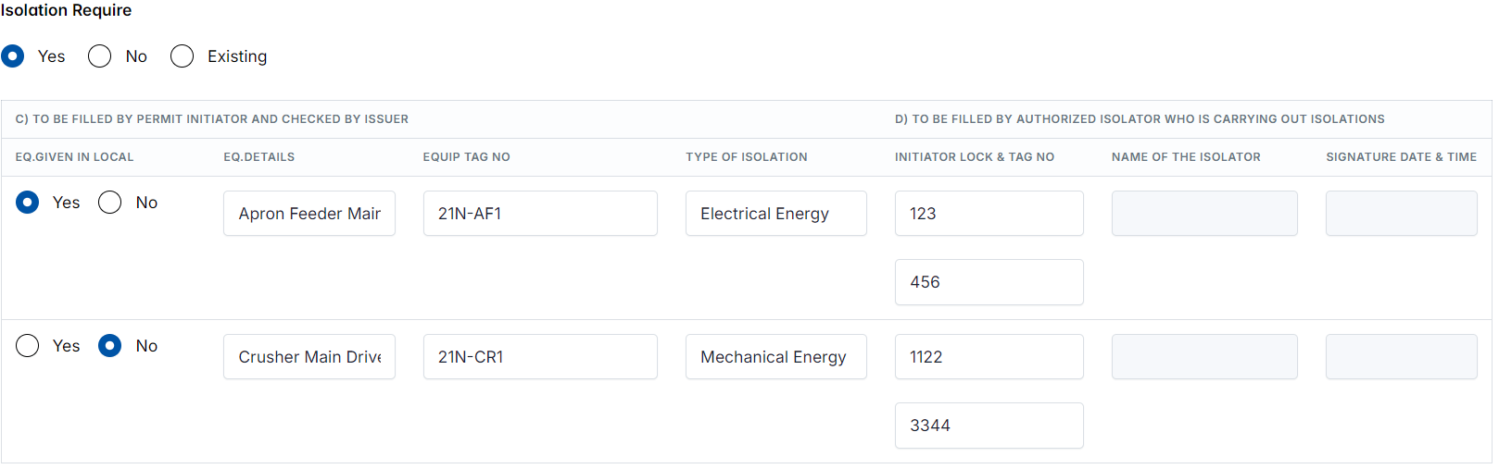

Yes – Show the isolation input section

No – Hide the isolation inputs

Existing – Will show the existing isolation in dropdown. Initiator can choose anyone of them from the listing



**Isolation inputs**

Eq. Details in Local . Yes/No

Eq. Details - Rendering from master. Initiator will be choose the eq

Eq. Tag No . Initiator will be fill

Type of Isolation. It’s fixed inputs like ‘Electrical Energy/Mechanical Energy/Chemical Energy/….etc’

PA Lock & Tag No – Initiator fill the values.

ISO Lock No – Isolator will be updating the value during in approval (Step 4)

Name of the Isolator – Issuer will be choose the isolator during in approval (Issuer – Step 3)

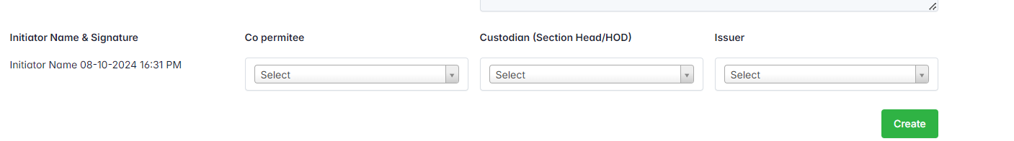

Initiator will choose the Co-permittee & custodians & Issuer from the dropdowns. Once, the initiator hit the “Create” button, new permit will be created and send notification to the custodian.

**STEP 2**

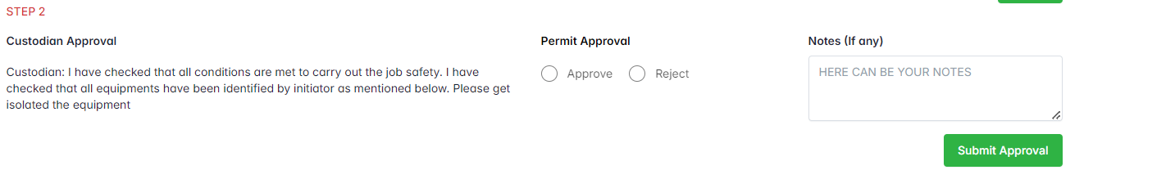

The custodian will review the Step 1 and correct if anything wrong and then give approval/reject the permit. If the reject the permit, the permit will be close automatically otherwise send approval notification to Issuer.

**STEP 3**

Issuer choose the isolator for each equipment’s and send approval notification to the isolators.

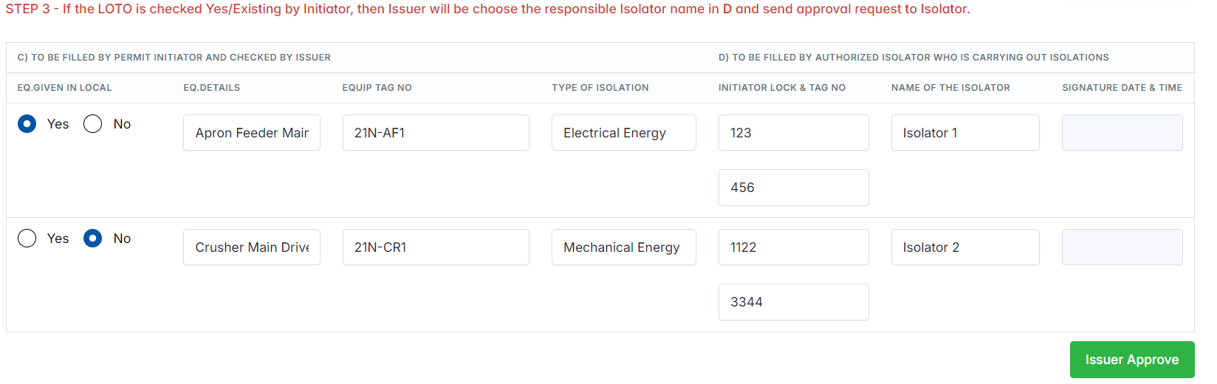

**STEP 4**

Isolator will review and approve it.

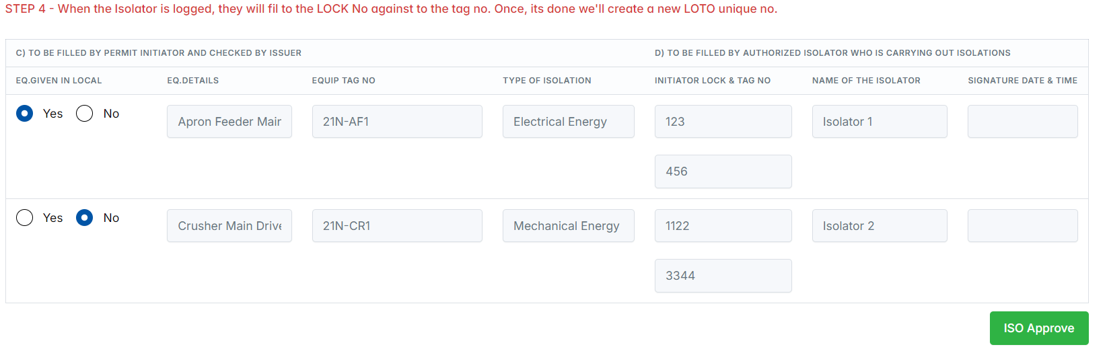

**STEP 5**

**Initiator will fill the below inputs and send approval request to Custodian. In case, if they choose “No”, then the permit status is changed to “HOLD”.**

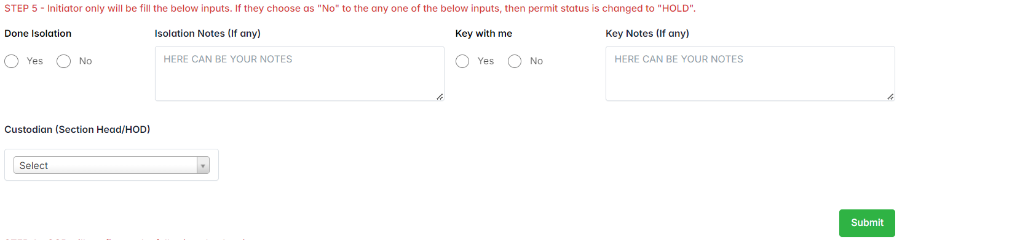

**STEP 6**

**Issuer will be fill the following checkpoints and forward to move next steps.**

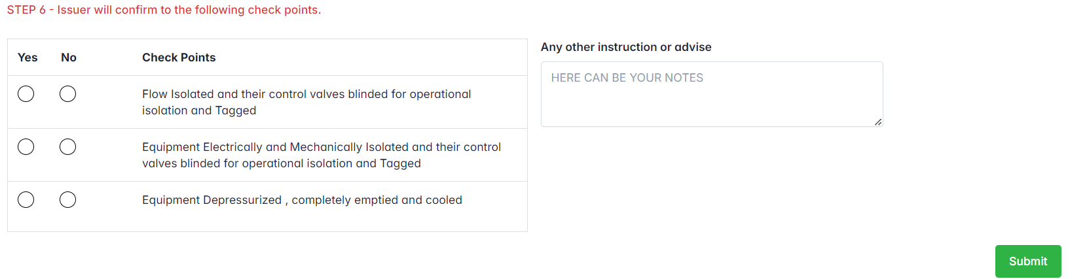

**STEP 7 & 8**

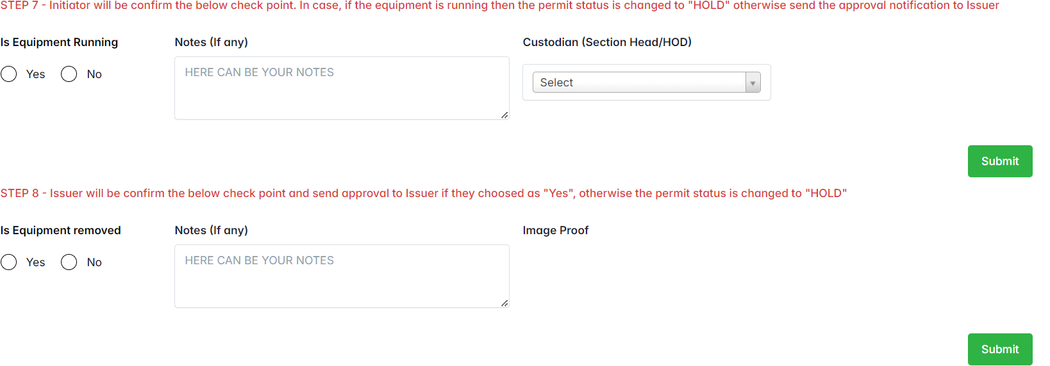

**Extend the permit**

**Currently, we’re allowing the initiator to extend the permit next 6days.**

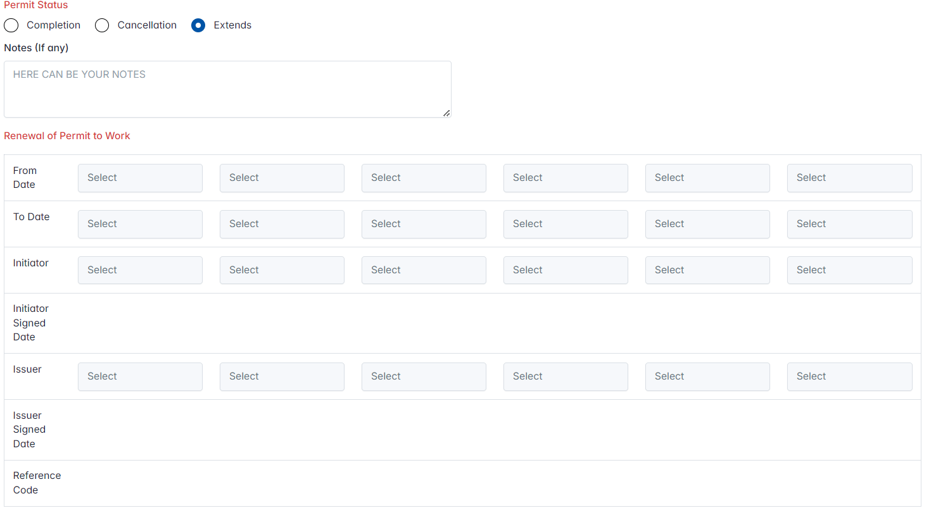

From Date – Current Date

To – Current/Next date

Initiator – Who is next responsible person to continue the permit work

Issuer – Name of the Issuer to approve the permit extends

Ref Code - Using the reference code the issuer will allow to work the permit in outside of the application.

**Closing the permit**

